LESSON PLAN

EDUCATOR: Kyriaki Tsitsipa
LESSON/OBJECT: Ancient Greek in translation (Ancient Greek Drama (Tragedy): Euripides, Eleni)
Duration: 2 teaching hours

THEME  Teaching Unit Title: | Prologue, verses 83-128 (Teukros’ appearance, dialogue with Eleni) | CLASS: | 3RD Grade (Junior High School)
TEACHING GOALS

Α. As far as learning object is concerned | Students are expected to:  1. Recognise the people involved in the aforementioned scene  2. Track information being given by Teukros to Eleni  3. Comment on the attitude/behavior of Teukros towards Eleni (why does he hate her so much?)  4. Understand the difficult situation of Teukros (he is exiled from his island)  5. Realize the role of the gods (do they affect people’s lives;)  6. Realize the difference between “einai” (what actually happens) and “phainesthai” (how things look like)
Β. As far as ICT is concerned | Students are expected to:  1. Get accustomed to the learning environment of a interactive whiteboard, by becoming able to use specific tools  2. Get accustomed to the filling in of an on-line questionnaire (Google Forms)  3. Create, prompted by the text, stop-motions in a comic
Γ. As far as learning process is concerned | Students are expected to:  1. Develop communication skills  2. Cultivate co-operative practices (team spirit)  3. Develop their imagination as long as their creativity  4. Enhance their self-esteem
Class Organization

Two teaching forms are combined:
1. Teacher-centered (monologue, narrative teaching)
2. Combination of teaching methods (question-answer, student motivation)

Logistical Support

We used:
- Openboard software (Interactive Whiteboard)
- Toondoo software (http://www.toondoo.com/ ) , a comics creation application that can be used in classroom without installing a program on your computer
- «Google Forms» tool for the creation of an on-line questionnaire

STAGES-STEPS
- INTRODUCTION (duration in minutes)-
(preparation/ brief introduction/
stimulation of students’ interest)

The teacher reads the text carefully. In specific, students have been given an adaptive form of the text included in the school book. The text was created according to guidelines of an “Easy To Read Text” so as to be accessible to students with Special Educational Needs (SEN) (10-15΄).

- DETAILED PRESENTATION (duration in minutes)
The specific lesson plan is mainly based on students’ practical workplace, using the tools of an interactive whiteboard. Our teaching goals are beyond of the analysis and interpretation of the text (what Euripides means, which is the deepest meaning of his tragedy). Not to mention that this lesson was planned in order to adapt to students with SEN (Special Educational Needs).
- PRACTICE WITH GUIDANCE (TEACHER’S SUPERVISION)
The teacher asks students to read the text by turns, using some of the applications / tools, provided by the interactive whiteboard (magnifying glass) to make it easier for them to read the text. It should be noted that some students have great difficulty in reading the text and thus understand what the text means (20΄).

The teacher uses a tool useful for the creation of notes and guides students in order to track relevant information in the text. Students stand up one by one and underline the information, using specific tools. In parallel with the text there are relevant pictures (saved in the Openboard library) in order to enhance their understanding (visualization of information) (20΄).

Students visit the according webpage http://www.toondoo.comm in which an on-line comics creation application is available. Having completed the processing of the text’s meaning, students have ended up with four comic-strips. The teacher helps students choose the background, the characters and the dialogue boxes (30΄).

Below screenshots of the lesson stages / steps are available:

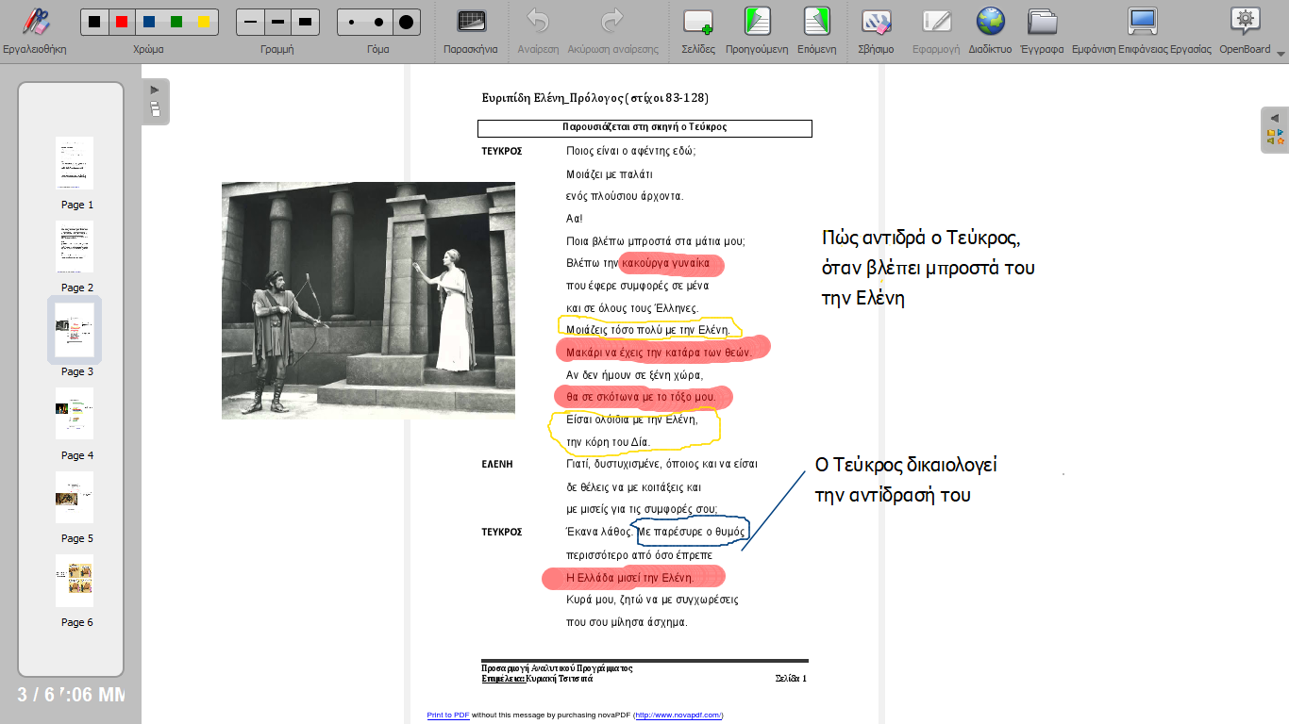

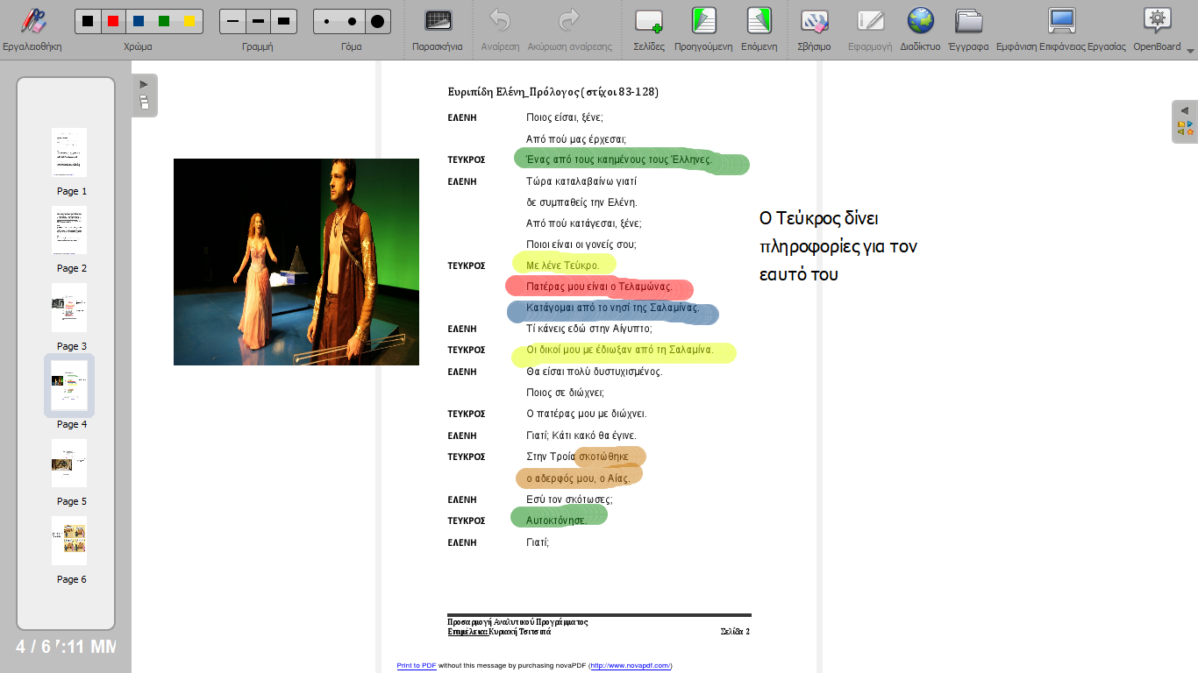

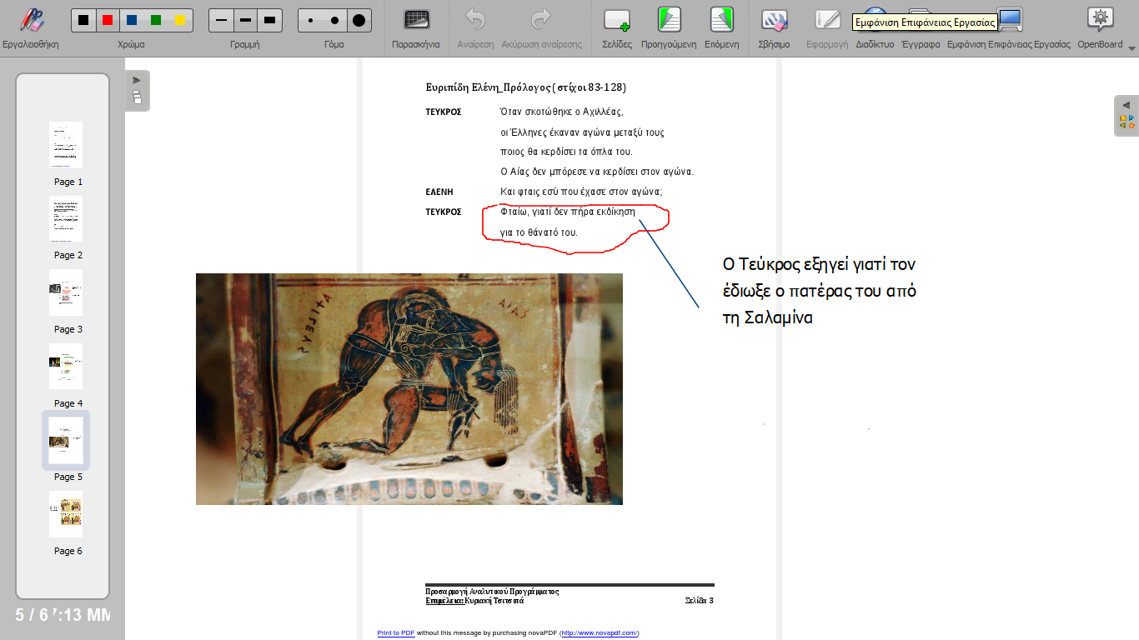

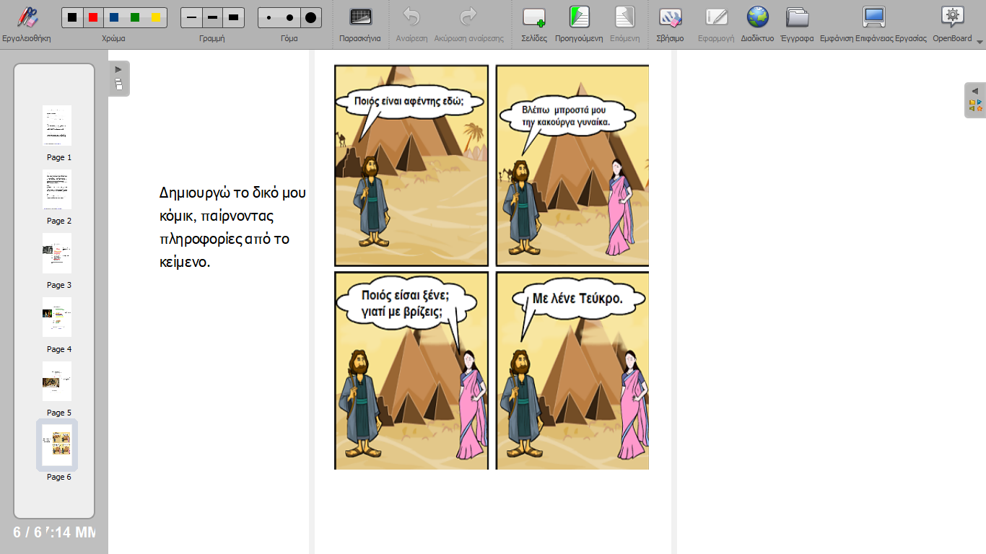

4.SUMMARIZATION
The teacher has created an on-line questionnaire which students are prompted to fill in within classroom. The questionnaire was created using the Google Forms application (15΄).

https://docs.google.com/forms/d/136k_BDjAU1COgmo3BT2KFoAvuXDP1Zn6xTXRp--frwk/edit

- PRACTICE WITHOUT GUIDANCE (TEACHER’S SUPERVISION (duration in minutes)
FURTHER ΝΟΤΕΣ

ICT  (tools used within classroom) | - Openboard software (Interactive Whiteboard)  - Toondoo software (http://www.toondoo.com/ ) , a comics creation application that can be used in classroom without installing a program on your computer  - «Google Forms» tool for the creation of an on-line questionnaire
SEN(Special Educational Needs)  (adaptations necessary in order to meet the needs of the students) | The text was created according to guidelines of an “Easy To Read Text” so as to be accessible to students with Special Educational Needs (SEN)
WORKSHEETS (homework)
Fill in the gaps in the following sentences, using words of the text above.
- ………………..appears on the stage.
- Teukros blames ……………… that se brought ………….to the Greeks and himself.
- Teukros calls Eleni a ……………….. woman.
- Teukros says that Eleni looks…………….. Zeus’..................
- …………………is Teukros’ father.
- Teukros comes from the island of ……………………….
- Telamonas has ……………… Teukros from Salamina.
- Teukros had a brother, called ……………….
- Teukros’ brother……………………….
- Telamonas has kicked Teukros out of Salamina (his island) because he didn’ t take……………….for the death of his brother.

*the structure of the lesson plan is based on the “Hunter method”

………………………………………………
Special Education Vocational Junior-Senior High School of Trikala
(the official stamp)

