COURSE PLAN

LESSON/OBJECTIVE:BIOLOGY
COURSE Duration: 4 teaching hours

Subject/  Name of teaching part | Human environment interventions-  Air pollution/  Greenhouse effect | ΤΑΞΗ: | 3rd Grade of Middle school
Course Objectives

Α. According to the subject matter | - What is greenhouse effect and why it took this name?  - Ways of counting the temperature of atmosphere  - What are photons?  - I write down the gathering of greenhouse fumes  - The meaning of glasswork in the greenhouse effect.
Β. According to the use of new technologies | 1. I learn what simulation is through a computer  2. I install a program and I follow the instructions, step by step in a simulation program.
Γ. The learning process | 1. What is the simulation and how it helps us to understand an effect?  2. I develop my observation, focus on a picture and come to conclusions
Class Organization

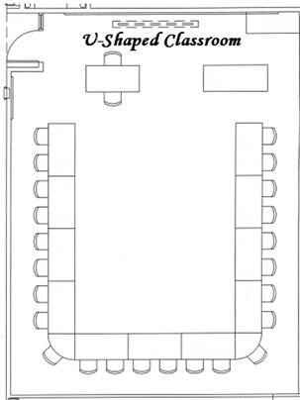

- Students feel that they are close to the teacher
- Discuss while having optical touch
- Dialectic type of teaching with questions and answers

Tools and Software used

- The simulation of « greenhouse effect» from PHET

http://phet.colorado.edu/el/simulation/greenhouse.

In order to install a program and see the simulation in your computer push ‘’capture”.
The homepage is the following:

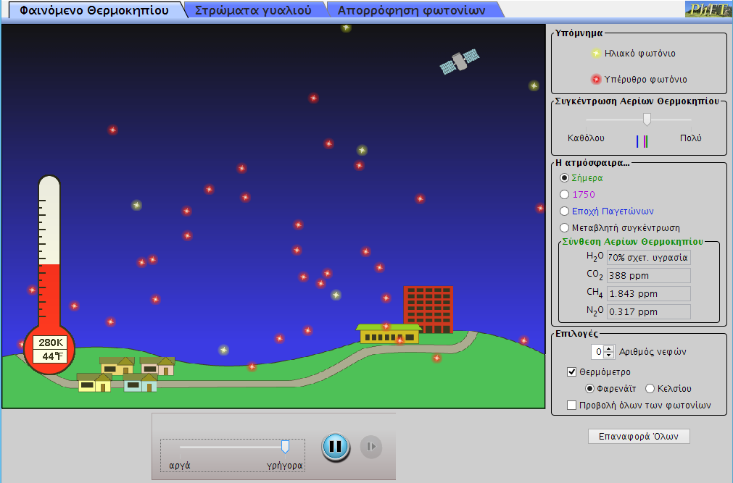

- Slide player

PHASES-STEPS
- INTRODUCTION- (preparation/ brief introduction/to stimulate the students interest)

https://www.slideshare.net/guesteb2b021/and-more
Watch the video in order to prepare students what the greenhouse effect is. We ask them to see only the pictures and answer a few questions.
- Why did it take this name? Greenhouse effect
- Who gave this name and when?
- We ask them to explain with our help the pictures of slide 3.
- We display together, in a simple way, the environment consequences of greenhouse effect: the thaw of meltwater, climate change.

- DETAILED PRESENTATION
Activity 1
Greenhouse effect
In the homepage of greenhouse effect, choose in the atmosphere the category ”Today”
In the first application card:
- choose the temperature mark in Celsius
- mark the «projection of photons»
- press the button of player which you see under the picture

Afterwards, as you have noticed the screen, answer the following questions.
- Which is the name of yellow photons that move down?
- Which is the name of red photons that move up?
- Look the thermometer and write down the temperature.
- Watch the right part of screen and write down the inventory of greenhouse fumes in ppm (
Parts in million).

H₂ O……………………………………………………………………………………………

CO₂…………………………………………………………………………………………….

CH4…………………………………………………………………………………………………………………………………………….

N₂O……………………………………………………………………………………………..

- As you wait the temperature to be stabilized, write down the temperature of thermometer.

K………………………………………………………………………………………………

⁰F………………………………………………………………………………………………

⁰C………………………………………………………………………………………………

Then, in the homepage of greenhouse effect, choose in atmosphere the category “1750”

- Watch the right part of screen and write down the inventory of greenhouse fumes in ppm (parts in million).

H₂O…………………………………………………………………………………………….

CO₂………………………………………………………………………………………..

CH₄…………………………………………………………………………………………

N₂O…………………………………………………………………………………………

- After waiting the temperature to be stabilized, write down the temperature of thermometer.

K………………………………………………………………………………………………

⁰F………………………………………………………………………………………………

⁰C………………………………………………………………………………………………

In the homepage of greenhouse effect, choose in atmosphere the category “The ice age”

- Watch the right part of screen and write down the the inventory of greenhouse fumes in ppm (parts in million).

H₂O…………………………………………………………………………………………….

CO₂………………………………………………………………………………………..

CH₄…………………………………………………………………………………………

N₂O…………………………………………………………………………………………

- After waiting the temperature to be stabilized, write down the temperature of thermometer.

K………………………………………………………………………………………………

⁰F………………………………………………………………………………………………

⁰C………………………………………………………………………………………………

- GUIDANCE PRACTICE/TRAINING
Activity 2

Glass sheets
After you choose the card “glass sheets”, you can see in the screen this picture

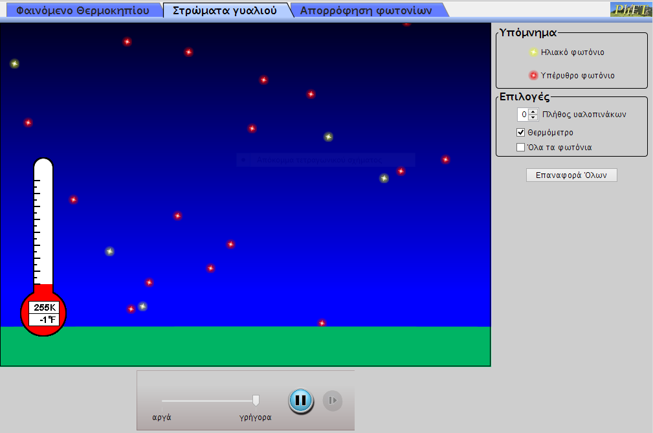

10.Write down the temperature of thermometer when there is no pane

K………………………………………………………………………………
°F ………………………………………………………………………………
°C………………………………………………………………………………

4.CLOSING AND RESTATING WHAT HAS BEEN LEARNED
The teacher makes a restatement, with a short and comprehensive way, pointing to the most important things. We ask for maybe questions.

PRACTICE WITHOUT GUIDANCE

Then, check the choice “glass sheets” the “glazing of sheet glasses”

- Watch the photons. Where is the place of their incident and where do they emanate? Does they cross in the glass or not?
………………………………………………………………………………………………….

- After waiting the temperature to be stabilized, write down the temperature

K………………………………………………………………………………...............................................
°F ……………………………………………………………………………….............................................
°C……………………………………………………………………………….............................................

13.Watch the temperature after the assignement of glass sheets and write which is the meaning of glass sheets in greenhouse effect.
...................................................................................................................................................................

ADDITIONAL NOTES
ICT and Technology  (used in the class) | Computer per a student  Projector
For Special Educational Needs  (change teaching methods based on the learning needs of each individual student with SEN) | - The students take as many time as they need without time press  - We avoid to create them stress or angst. The teacher is there and helps the student. He comments them for their success trial.
HOMEWORK/WRITTEN PRODUCTION

*the structure of the lesson plan is based on the “Hunter method”

