COURSE PLAN

LESSON/OBJECTIVE: GEOGRAPHY-GEOLOGY
COURSE Duration: 2 teaching hours

Subject/  Name of teaching part | NATURAL ENVIRONMENT - ATMOSPHERE | ΤΑΞΗ: | AGrade of Middle school
Course Objectives

Α. According to the subject matter | Students should be able to:  - learn to briefly describe the climate in different regions of Greece  - distinguish climate differences across regions  - compare them and draw conclusions about climate in these areas.  - learn to read and understand texts of the National Meteorological Service, and  - use climate datasets to draw conclusions on climate and climate change in different regions of Greece during different seasons of the year.
Β. According to the use of new technologies | Students are expected to:  1. Navigate in a simulated environment.  2. To find similar browsing websites related to learning the subject
Γ. The learning process | Students are expected to know how:  1. Each region of Greece may differ in its climatic conditions from other areas of our country.  2. They can describe the climatic conditions of an area by collecting statistics on the conditions prevailing in each of them and record them in climatic tables.
Class Organization

Two forms of teaching combinations:
1. Teacher-centered (monologue- narrative teaching)
2. Mixed (question and answer teaching, student attendance)
3. Research
4. Synergistic

Tools and Software used

Resources used:
1. The Klima_exe simulation software
2. Computers

PHASES-STEPS
- INTRODUCTION- (preparation/ brief introduction/to stimulate the students interest)
The child's workbook should first be created.

- DETAILED PRESENTATION
A) Individual activity
The worksheet is distributed to all children and children are invited to work on some individual activities. In particular, they are asked to answer 4 questions in writing in order to trace their initial knowledge (or even the final, if the questionnaire is distributed to students at the end of the lesson), on the different climatic conditions prevailing in various parts of Greece.

B) Computer-based group activities: Children are put into groups of 2-3 in front of the computer and are given the student worksheet, which includes group activities on the computer. The children then activate the simulation klima_2.exe. The purpose of their work with this simulation is to study the different climatic regions of Greece in order to be able to compare these regions. The ultimate goal of the activities is for the children to understand that the above differences are mainly due to factors such as distance from the sea, altitude, relief, mountain ranges, local winds, etc.
Additional resources on the Internet

a. Websites where there are geophysical maps of Greece are
http://www.robolo.org/inforest/map/raster/grelev2.png
http://www.in.gr/agro/Mapp.swf

b. The website of the National Weather Service is:

http://www.hnms.gr/hnms/greek/climatology/climatology_html

c. The website of the Ministry of Environment and Physical Planning of Greece contains material related to the climate regions of Greece:

http://www.minenv.gr/1/12/121/12103/g1210306.html

- GUIDANCE PRACTICE/TRAINING
The simulation klima_2.exe
The simulation of klima_2.exe shows the map of Greece, which distinguishes the different regions with different climate: Mountainous, Inland Mediterranean, Continental, Maritime and Mediterranean regions. Each time you click the mouse cursor on one of the boxes next to these titles on the map, an explanation of the climate in those areas is displayed at the top right of the screen (Figure 1 explains what the climate in the highlands is).

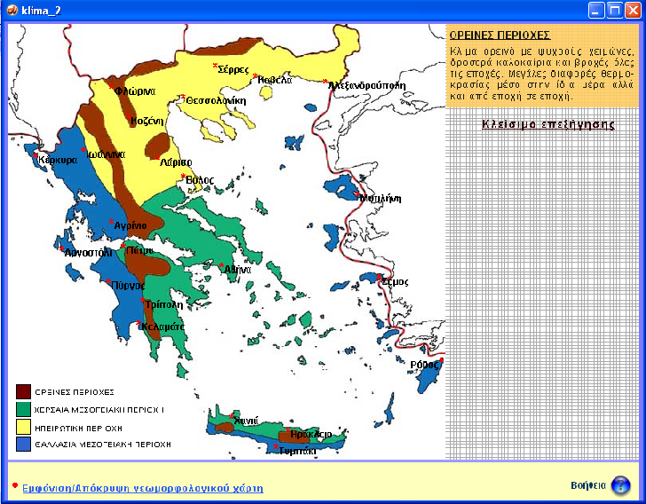

Figure 1. Simulation of klima_2.exe
The user can choose to display the geophysical map of Greece by activating the relevant key in the lower left of the screen. It can also turn on Help to get information on what it can do and how to do it.

The map shows the names of the main cities of Greece. Clicking on one of these cities will show two windows with a diagram on the right of the screen. The top chart shows the average temperature fluctuation (in degrees Celsius) for all months of the year in the selected city and the second millimeters of rain) each month of the year in the selected city. For example, in Figure 2 Athens is selected for the region whose diagrams of average temperatures (in degrees Celsius) and average rainfall values ​​over the 12 months of the year are shown

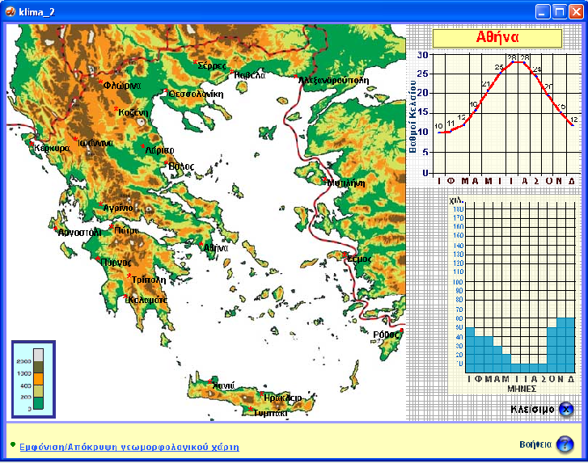

Figure 2. Simulation of klima_2.exe. Average temperatures (in degrees Celsius) and average rainfall (in millimeters of rain) during the 12 months of the year in Athens.

4.CLOSING AND RESTATING WHAT HAS BEEN LEARNED
Ask students to brainstorm and get questions and answers from students in the form of a knowledge game (worksheet questions) in groups to develop collaborative relationships.
ADDITIONAL NOTES
ICT and Technology  (used in the class) | Computer per a student  Projector
For Special Educational Needs  (change teaching methods based on the learning needs of each individual student with SEN) | This lesson will be taught in 3 hours and we will focus on the key points.  The worksheet will also be completed during the allotted time.
HOMEWORK/WRITTEN PRODUCTION

Α. INDIVIDUAL ACTIVITIES

Α.1 Have you heard the word climate? Yes No
In your opinion, what does the word climate mean?
…………………………………………………..................………………………………………………..

Α.2 Have you ever travelled to a different part of Greece where the climate was different from where you live?

Yes No

If your answer was Yes, then in what area of Greece?
…………………………………………………..................………………………………………………..
…………………………………………………..................………………………………………………..

Α.3 Which parts of Greece do you believe have a different climate then where you live?
…………………………………………………..................………………………………………………..
…………………………………………………..................………………………………………………..
Α.4 Where do you think these differences in climate are due to?
…………………………………………………..................………………………………………………..
…………………………………………………..................………………………………………………..

Α.5 In which areas of Greece do you think it is cold in the winter? Why?
…………………………………………………..................………………………………………………..
…………………………………………………..................………………………………………………..
Α.6 In which area of Greece do you think it has the hottest summers? Why?
…………………………………………………..................………………………………………………..
…………………………………………………..................………………………………………………..
GROUP ACTIVITY
B. Climatic regions of Greece
B.1 Open the simulation entitled "Climate of Greece". After the first introductory screen a map of Greece with its climate regions appears. On the map, locate the city or area where you live (if the name of the area where you live does not exist, select the city closest to it).

http://photodentro.edu.gr/lor/r/8521/6822?locale=el
B.2 Select the city by clicking. The graphs of the mean monthly temperature and rainfall are then displayed.
Review the charts and complete the following sentences:
a. The city we chose is: ……………………………………………………………………………………………………… …… ……………………………………………………………… ..
b. Located in the climate zone colored ........................................... .......... and features ……………………………………………………………… ... …………………………………………

………………………………………………..................………………………………………………..

C. The temperatures for Winter and Summer months are the following: Complete the table.
WINTER | Temperature/Celsius |  | SUMMER | Temperature/Celsius
DECEMBER | ........ |  | JUNE | ........
JANUARY | ........ |  | JULY | ........
FEBRUARY | ........ |  | AUGUST | ........

D. The rainfall for Winter and Summer months are:
WINTER | Rain in mm. |  | SUMMER | Rain in mm.
DECEMBER | ........ |  | JUNE | ........
JANUARY | ........ |  | JULY | ........
FEBRUARY | ........ |  | AUGUST | ........

E.The area you live in is near or far
(underline the correct answer)
F. The area you live is a highland or lowland?
B.3 Have a chat with your group and answer the following question:
What do you conclude about the climate in your area? (also use the words: short - long sea, mountainous - lowland, cold - mild winter, cool - warm - humid - dry summer)

…………………………………………………..................………………………………………………..
…………………………………………………..................………………………………………………..
…………………………………………………..................………………………………………………..
…………………………………………………..................………………………………………………..

B.4 Select Show on the Geophysical Map again to show the map of climate zones, and then search to see which climate zone is the area where you live.

…………………………………………………..................………………………………………………..
…………………………………………………..................………………………………………………..
B.5 Compare the description shown in the memo with the one you just wrote. Note any differences below.

C. Comparison of climatic regions of Greece
C.1 In the "Climate of Greece" simulation select Climate Regions of Greece.
Choose from a city for each climate region.
Study the climatic elements of the cities and fill out the following tables accordingly.

……………………………………………..................………………………………………………..
CITY: .............................
WINTER | DEC | JAN | FEB
RAIN
TEMPERATURE
SUMMER | JUNE | JULY | AUG
RAIN
TEMPERATURE
CITY: .............................
CLIMATE AREA  .......................................... | CLIMATE AREA  ..........................................

WINTER | DEC | JAN | FEB
RAIN
TEMPERATURE
SUMMER | JUNE | JULY | AUG
RAIN
TEMPERATURE

CITY: .............................
CLIMATE AREA
..........................................

WINTER | DEC | JAN | FEB
RAIN
TEMPERATURE
SUMMER | JUNE | JULY | AUG
RAIN
TEMPERATURE
CITY: .............................
CLIMATE AREA
..........................................

WINTER | DEC | JAN | FEB
RAIN
TEMPERATURE
SUMMER | JUNE | JULY | AUG
RAIN
TEMPERATURE

Select the map legend to see the description of each climate region.

http://www.hnms.gr/hnms/greek/index_html
Compare this description with the data you gathered in the tables above.
Does each description match the items you have in the tables?
If there are differences please note them below:

…………………………………………………..................………………………………………………..
…………………………………………………..................………………………………………………..
…………………………………………………..................………………………………………………..

As you will see, there are significant differences in the climate of the different regions of our country. These differences are mainly due to the factors you have studied in previous activities (distance from sea, altitude, relief, mountain ranges, local wind) etc.

*the structure of the lesson plan is based on the “Hunter method”
http://photodentro.edu.gr/lor/r/8521/6822?locale=el

